1. What is the seat number that you are sitting on in class: We need this for ISU:

1. What are the most common mistakes students do when starting at the university?

1. Looking at the cycle of inquiry, what are your felt difficulties? Please express and reflect on them

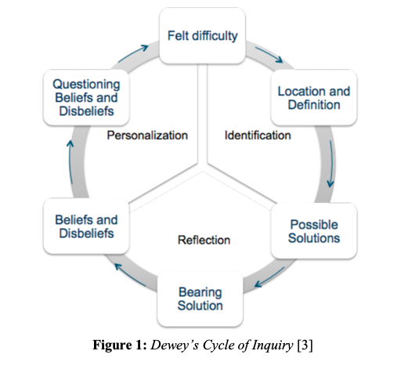

1. Let us see our reasoning and solving a problem. If Jill does a job in 15 minutes, and John does it in 45 minutes. How long would it take them if they work together? Show your work, and detail.